TASK PERFORMANCE

Human Factors in HCI

Technological Developments / Innovations:

1. Steam Proton
2. Steam Deck
3. Framework Computers

========================================================================

1. **STEAM PROTON**
2. **Image of the Technology/Innovation.**



1. **Features of the Technology/Innovation:**

* Free and Open Source Software ( **FOSS** )
* Makes games that are made for windows compatible and able to run on Linux

These features can satisfy numerous developers and/or users as its free and open source. This software also is a compatibility layer that makes games that only runs on windows be able to run as well on Linux. This makes the people who wanted to stay away from windows and/or moving over to Linux be able to play most of the games that they’re playing over from windows.

1. **Connections of interactive interface of the technology/innovation**

The interactive interface of this software just eases the steps in setting up the environment for the games and/or softwares to be able to run on Linux, well, mainly games. Usually, you will need to enter lots and lots and lots of commands just to be able to run the game you want. Now that Proton finally came out, Steam’s stocks continued to go up and this software helped a lot of developers and users at the same time.

1. **References**

https://www.protondb.com/. (n.d.). https://www.protondb.com/

========================================================================

1. **STEAM DECK**
2. **Image of the Technology/Innovation**

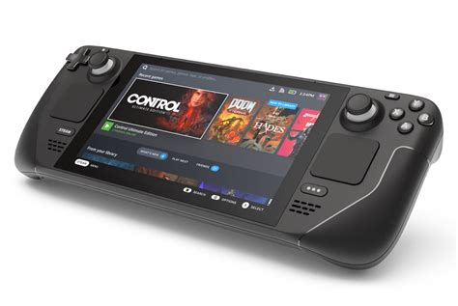

1. **Features of the Technology/Innovation**

* Portable
* Small and Lightweight compared to Laptops

This hardware contains these features and are being loved by numerous people, no matter if they are daily driving windows or Linux. Most of the games are on steam and a team of steam developers are developing a compatibility layer that makes these games run on Linux! This device is also very lightweight compared to Laptops, and, surprisingly, more high specced than most laptops.

1. **Connections of interactive interface of the technology/innovation**

The interface of this device is made with the users in mind. The steam team made the device easy to control and easy to navigate through without having knowledge with Linux. This device is using KDE, which is a desktop environment that has a lot of features for users to use which works for beginners as well as for the advanced users.

1. **References**

Steam Deck. (n.d.). Steam Deck. https://www.steamdeck.com/en/

**========================================================================**

1. **FRAMEWORK COMPUTER**
2. **Image of the Technology/Innovation**

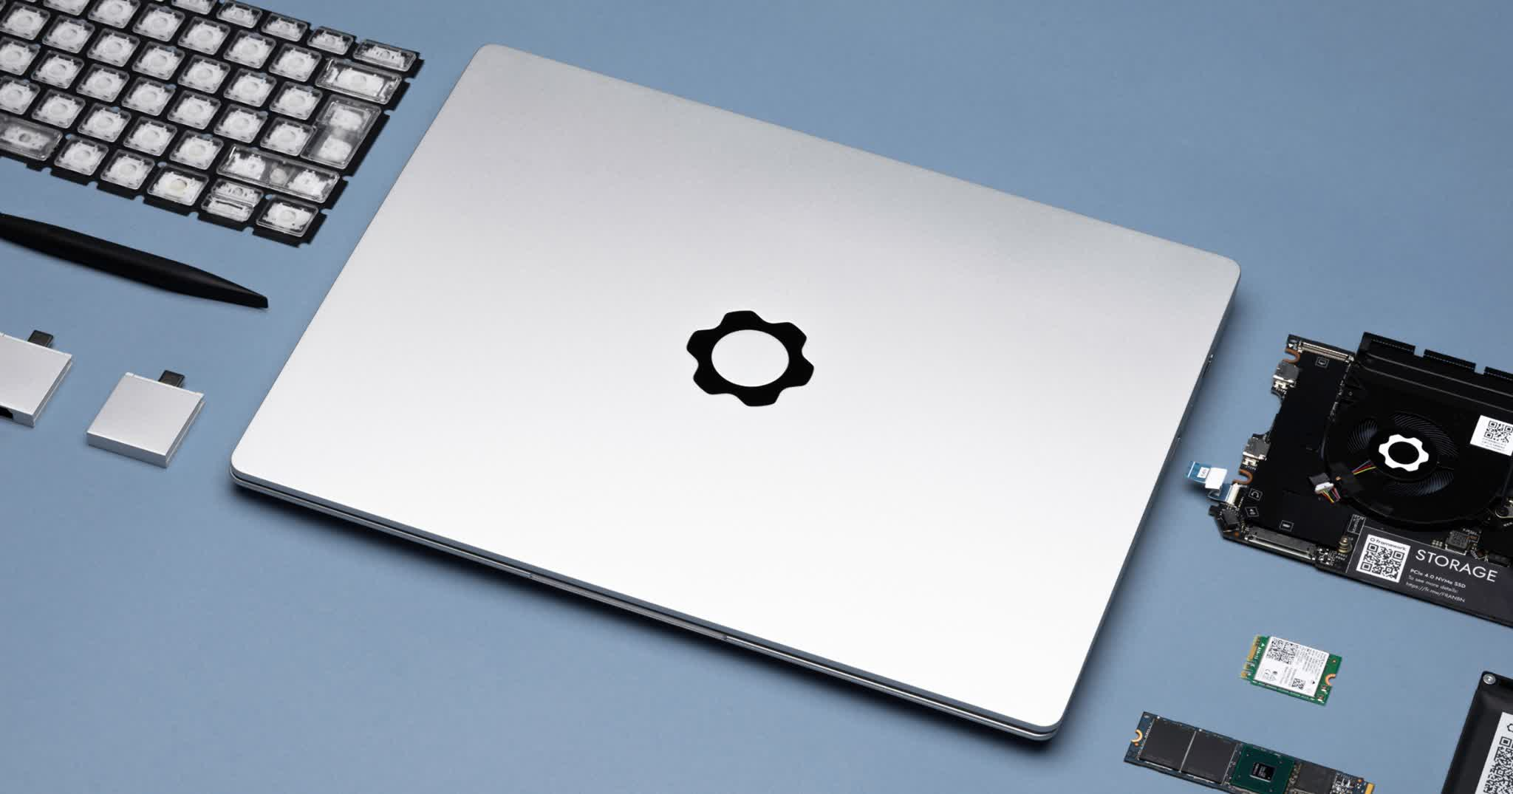

1. **Features of the Technology/Innovation**

* Configurability
* Right to repair
* OS Compatibility

This hardware is one of my favorite devices as it has this feature that most laptops these days don't have, which is its high configurability. The Framework company gives its users and/or customers the right to repair which, in theory, will enable its users and/or customers to save money. If your laptop’s parts breaks or have problems, you don’t have to buy a new laptop, instead, you can now just replace what is wrong in your laptop!

1. **Connections of interactive interface of the technology/innovation**

This device’s interface is just the same as any other laptops, the only difference was your ability to replace its parts and OS freely. Well, you can change your OS on most laptops but Microsoft kind of restricts this by requiring TPM to be enabled.

1. **References**

Framework Laptop 16 pre-orders are now open. (n.d.). Framework. https://frame.work/

I really think this Steam Proton will slowly revolutionize the gaming industry and Linux world. It has already started and it will only get better over time. While Microsoft and other big tech companies are moving towards using telemetry to collect its users’ and/or customers’ data and stuff, the Linux desktop world just keeps getting better and better, proof of it being Linux’s market share increasing by 1%.